**Policies and Permissions**

* **Creating a bucket**
* Create a new bucket in which we want to add policy with all default settings.

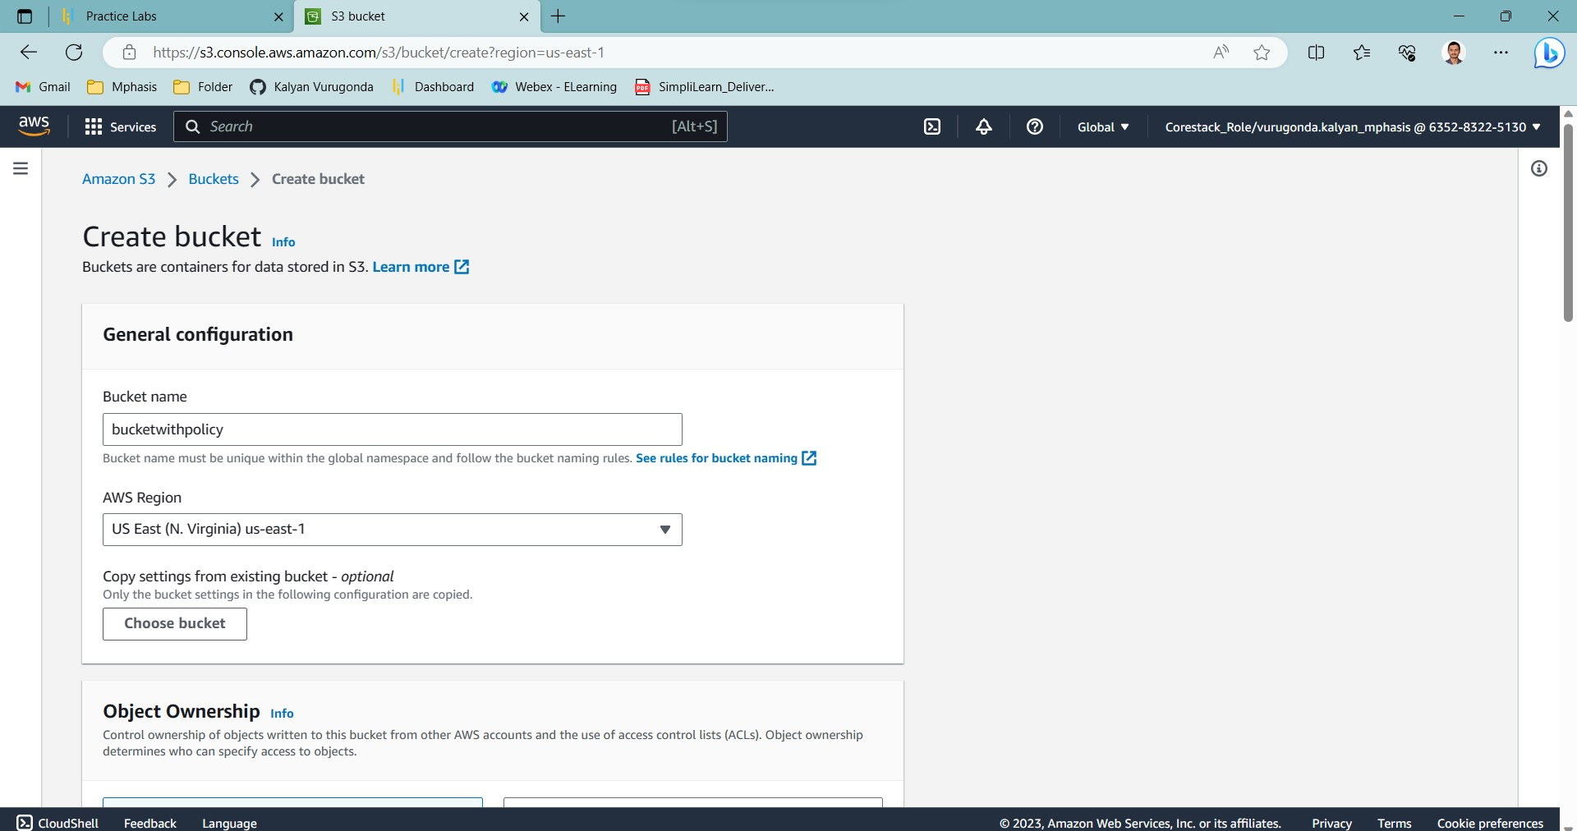

* Click on the Permission section.

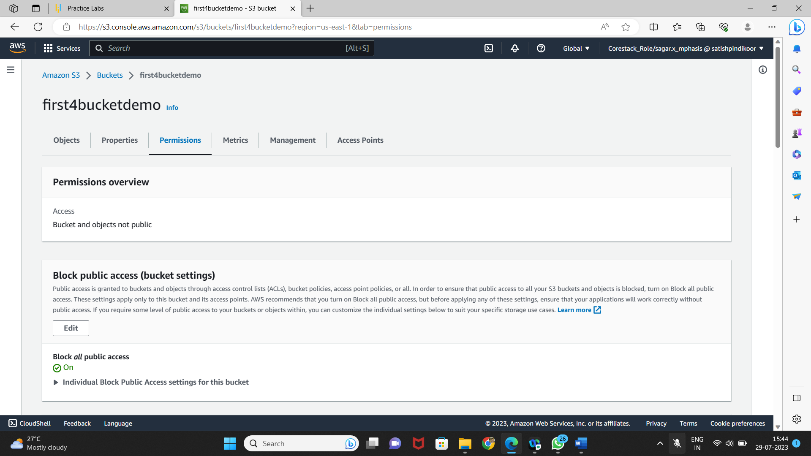

* Go to Bucket Policy.
* It will open the console where you can add policy.

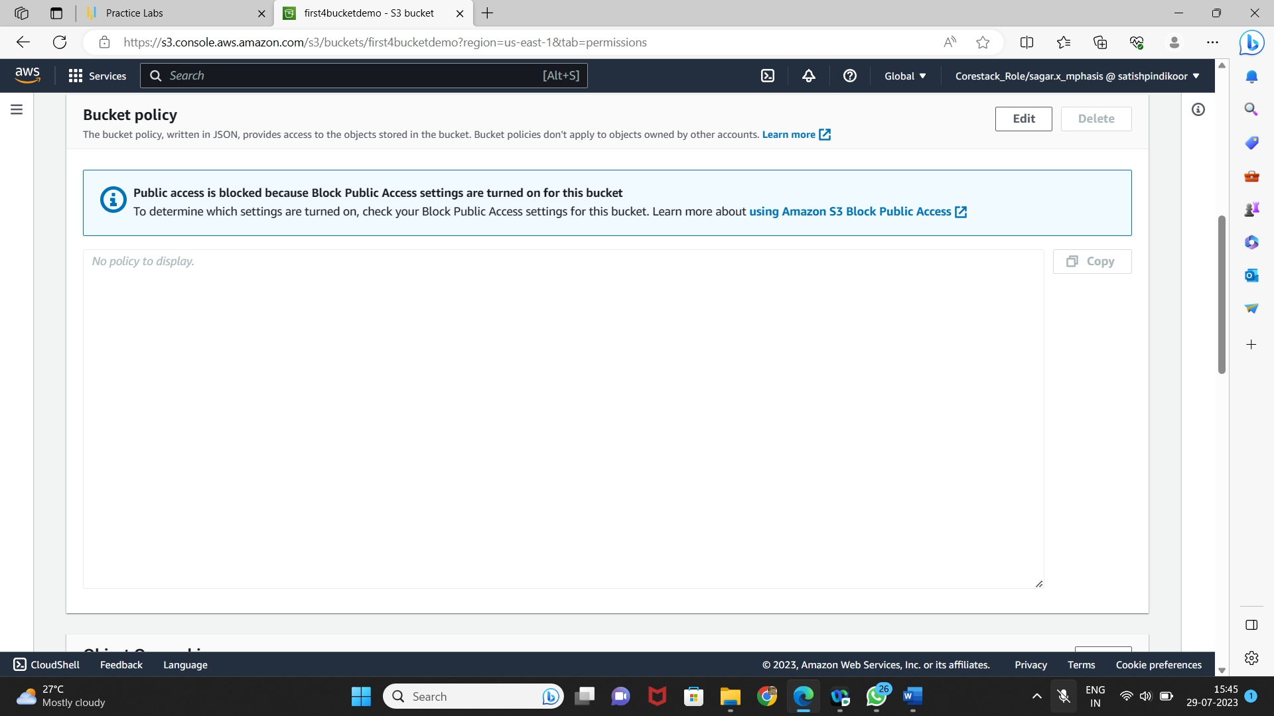

* **Adding policies**
* Click on the Policy Generator.

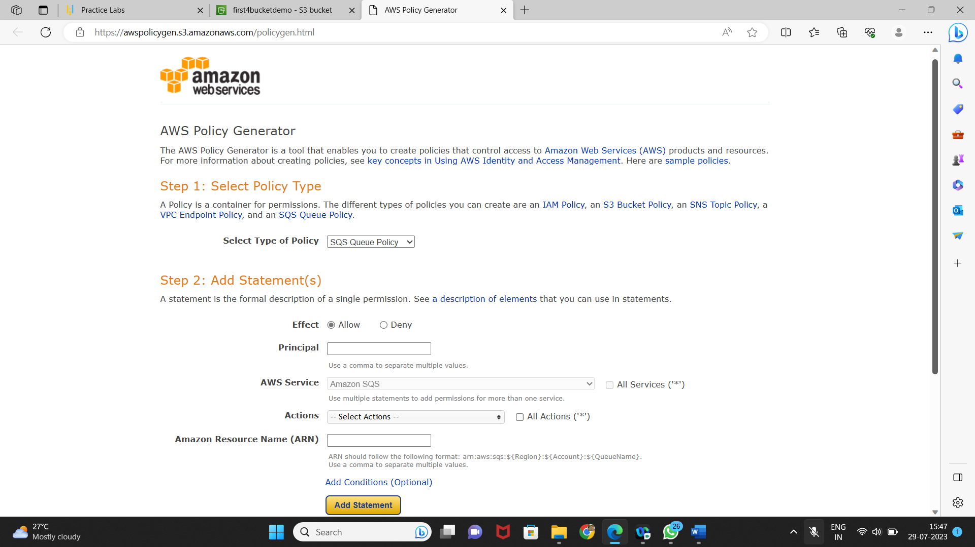

* Select the type of policy and services required.
* Add ARN for S3 to add the policy.

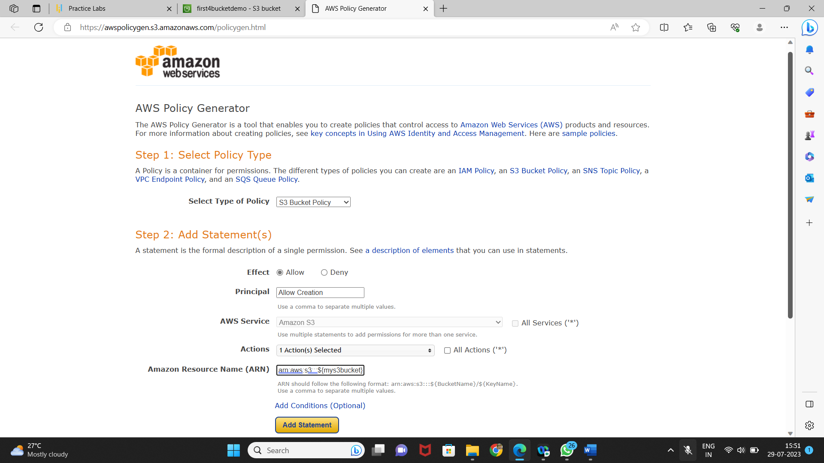

* Click on policy generator to create the JSON of the policy.

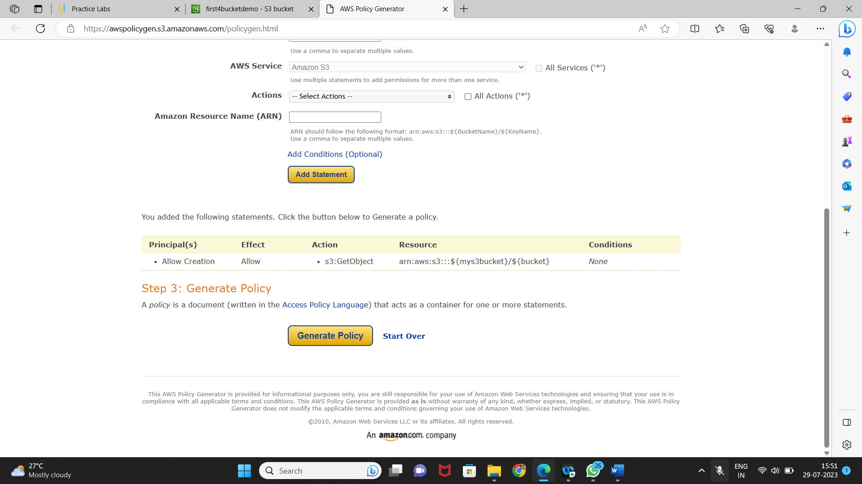

* Copy the generated JSON.

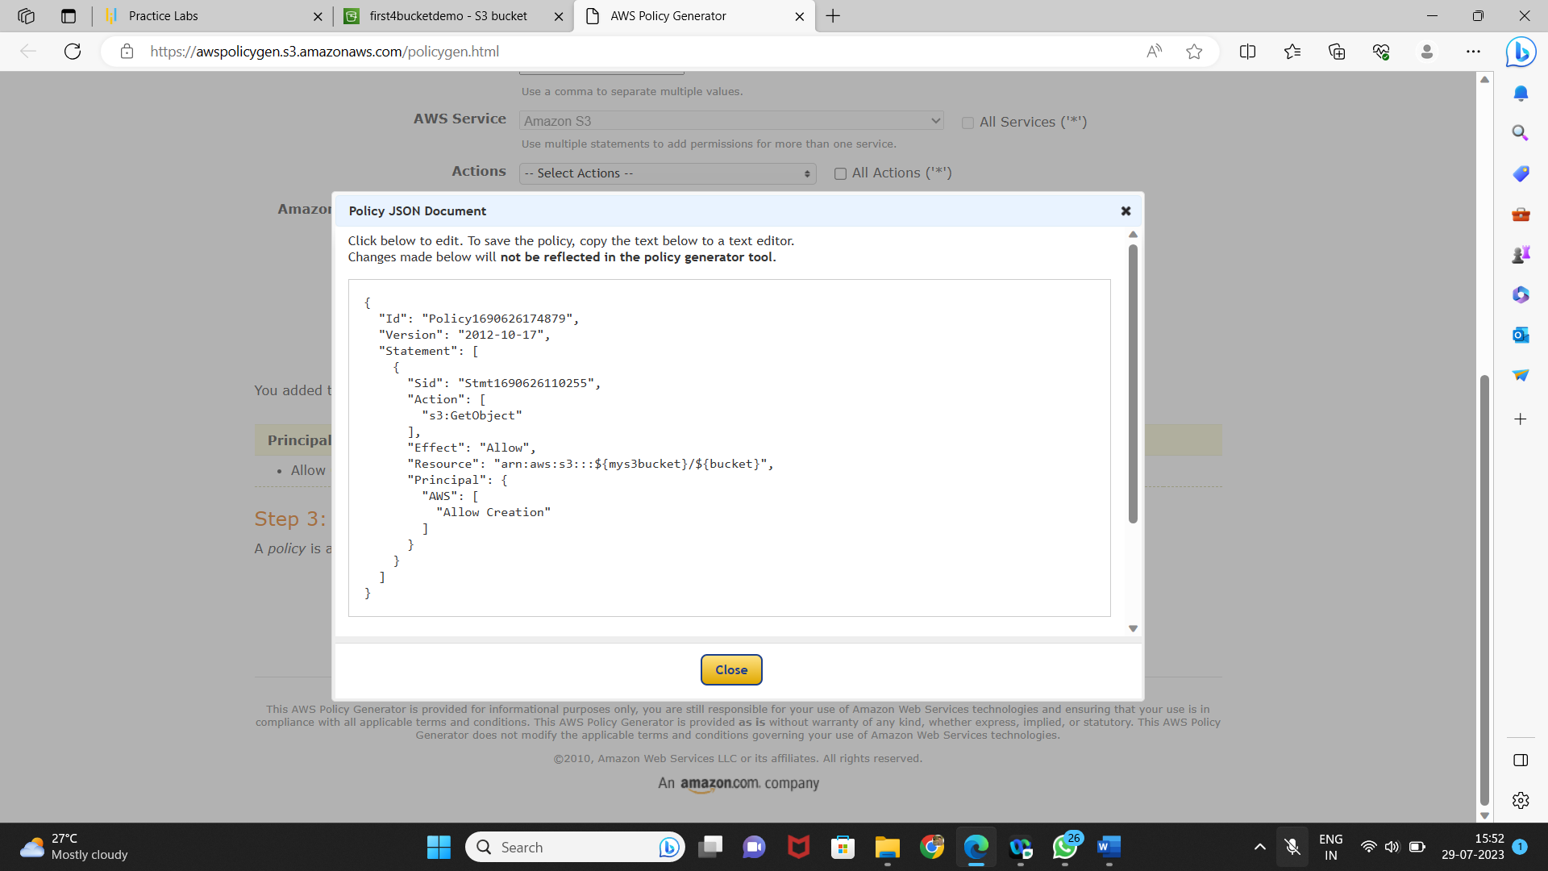

* Paste the JSON in the policy console of bucket and click on Save.

